- Product Overview
WIN-SN-XY-INCL-M is a compact, high-precision Inclinometer Sensor designed for accurate angular measurement in one or two axes. The sensor provides a digital RS485 Modbus RTU output, ensuring reliable and stable data transmission in industrial and IOT environments. Its low power consumption, compact form factor, and industrial-grade design make it ideal for platform leveling, vehicle tilt monitoring, and automation applications.
The sensor is fully calibrated, providing excellent repeatability and linearity over a wide temperature range.
- High-accuracy tilt measurement (single or dual-axis)
- Measurement range: ±90°
- RS485 Modbus RTU output
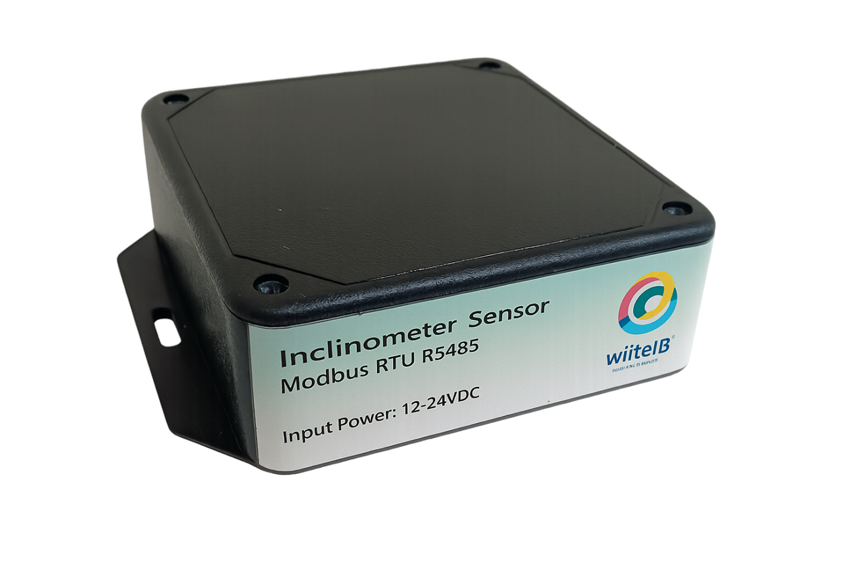
- Operates on 12V DC
Fig.1 - Product Image
Note – Ref Image only. (Actual enclosure design may change based on application use case.)

Measuring Parameter | Measuring Range | Accuracy
Inclination (X- Axis) | ±90° (90Deg) | ±0.1°
Inclination (Y- Axis) | ±180°(180Deg) | ±0.1°

2. Sensor Specifications
- Wide temperature range: −40 °C to +125 °C
- Full humidity range: 0 % to 100 % RH
- Power supply DC: 12-24V@1A.
- Product dimension: 100*100*60 mm.

- Certifications:

3. Power Supply Connection
DC Connection
- Use 12-24V@ 1A, Power supply.
- Don’t make loose connection.

4. Configuration Settings
- Communication Speed 9600 – 115200 Kbps (SW Selectable)
- Data Bits 8
- Parity None
- CRC Yes
- Slave ID 1, DIP (SW Selectable)
- Function Code 0X03 (Read Holding Register)

Recommended Cable Electrical Characteristics
22 AWG Cable Shielded and twisted pair should be used.
Tinned Copper Recommended
Nominal Conductor DCR 14.7 ohm / 1000 ft
Nominal Capacitance 11 pf / feet (conductor to conductor)
High Frequency Non-Insertion Loss 0.5db / 100ft
6. Modbus RS485 Data Storage register
ID | Function  Description | Register  Description | Modbus Function Code | Protocol | Data  Type
1 | Inclination X-Axis (°) | 40001 | 0x03 | RS485 | 16-bit int
2 | Inclination Y-Axis (°) | 40002 | 0x03 | RS485 | 16-bit int
3 | Set X & Y Axis 0 | 40003 | 0x03 | RS485 | 16-bit int
1 | Display Baud Rate (Default: 960) | 40011 | 0x03 | RS485 | 16-bit int
2 | Enter New Baud Rate | 40012 | 0x03 | RS485 | 16-bit int
3 | Display Slave ID (Default: 1) | 40013 | 0x03 | RS485 | 16-bit int
4 | Enter New Slave ID | 40014 | 0x03 | RS485 | 16-bit int
5 | Display Parity (Default: None-3 And for Odd-1, Even-2) | 40015 | 0x03 | RS485 | 16-bit int
6 | Enter New Parity | 40016 | 0x03 | RS485 | 16-bit int
7 | Display Stop Bit (start-2/stop bit-1) | 40017 | 0x03 | RS485 | 16-bit int
8 | Enter New Start/ Stop Bit | 40018 | 0x03 | RS485 | 16-bit int

7. Modbus Configuration
Here is an example of receiving data on Mb poll software.
- Open Mb-poll software connect using configuration setting (Default baud rate is 9600 and slave id is 1).
- After connecting you will get data as shown below.

Important Note
- If you want to enter the baud rate 9600/19200/38400/57600/115200etc, enter it like this 960/1920/3840/5760/11520etc.
- After that press the reset button or reboot the system.
- Then you will get the present value of 11520 at 40011 baud rate (115200) and 2 at 40013 slave id.
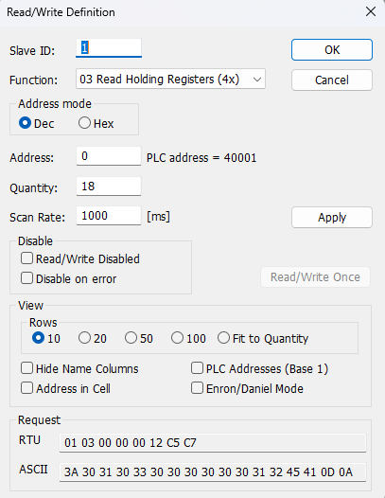
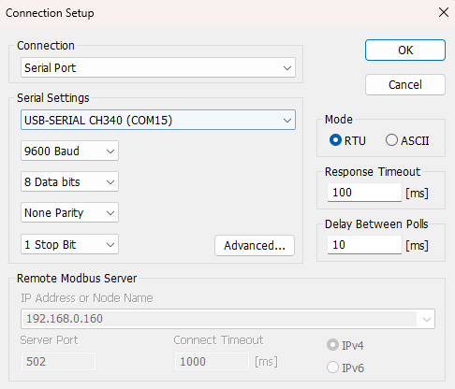

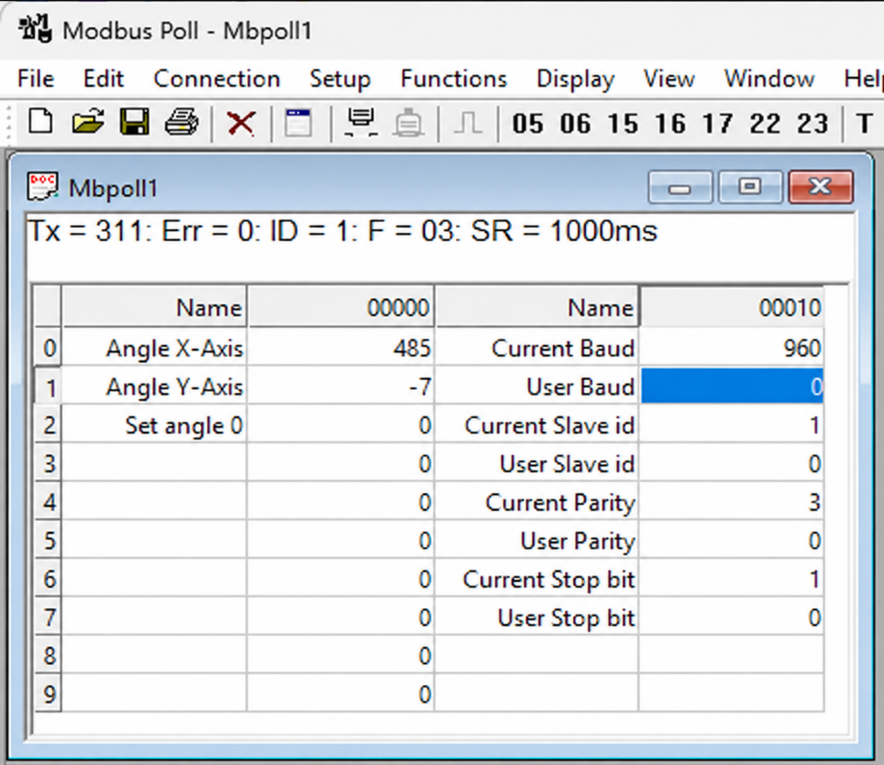

- Above image Shows sensor data over Modbus with default Modbus settings
- At the register 40001 shows Angle X, register 40002 shows Angle Y.
- The angle representation works like: if the angle is 48.5°, it will be shown as 485; if the angle is -0.7°, it will be shown as -7; if the angle is 121.1°, it will be shown as 1211
- At resistor 40003, you can set the X and Y angles to 0 and consider that position as the start angle. Once the module moves, the angles will update according to the module’s movement.
- To set the module position as the default 0° angle, place the jumper as shown in Image 1.2 and restart the device.
- As you can see in the image above, the resistor 40011 – 960 represents the present bund rate (9600) of the board and 40013 – 1 represents the present slave id of the board.
- To change the baud rate and slave id Jumper should be in single/removed then, you must enter a value on the 40012 resistors for the baud rate and 40014 for the slave id as shown in the image below and restart the board.
- Now you can see data below image set 115200 baud rate and slave ID 10.

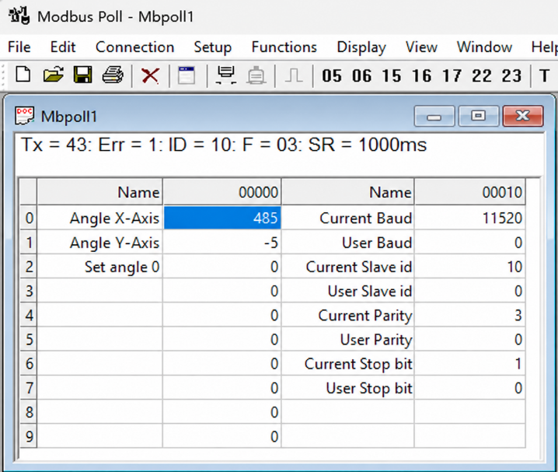
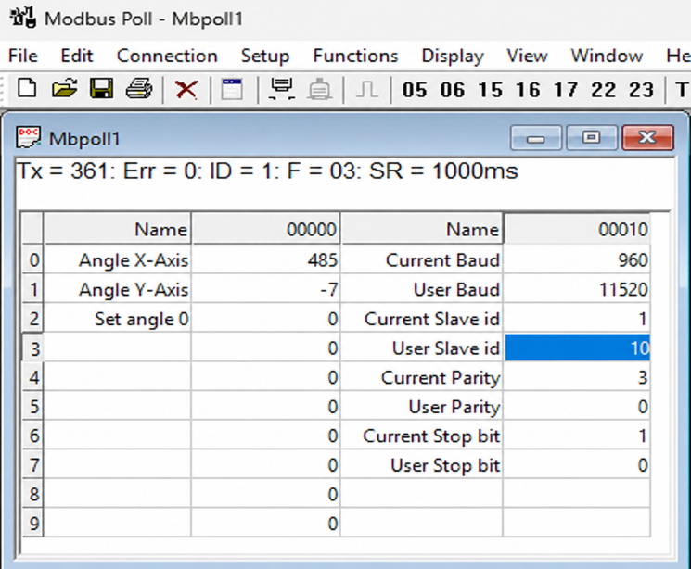

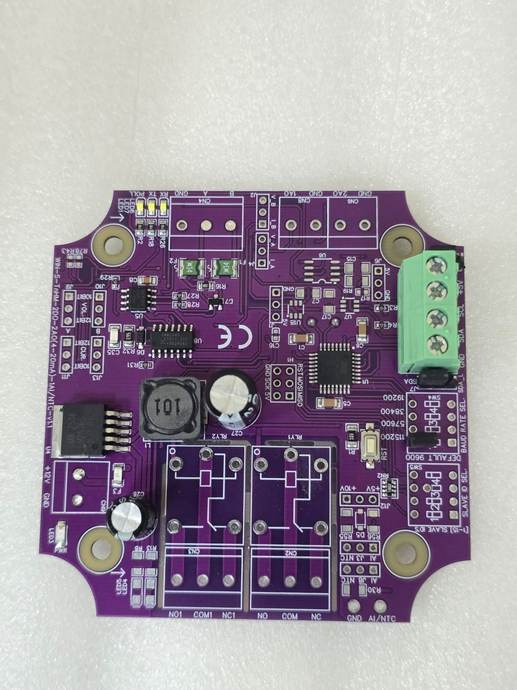
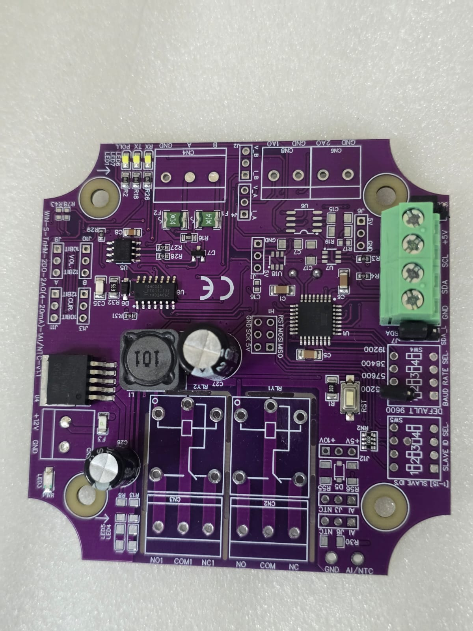

Closed
Open/Remove

Image1.1 Image1.2

Hard reset Setting
- Somehow you forgot the baud rate or slave id of the board then Place the jumper (as shown in the image 1.2) from the board reboot the system or press the reset button (given on the board). Then you will get the default baud rate of 9600 and slave id 1.

Contact Information
Augmatic Technologies Pvt. Ltd.,
Plot no 6, Shah Industrial Estate II,
Kotambi,
Vadodara – 391510.
Email – Sales@wittelb.com
Support: support@wittelb.raiseaticket.com / +91 94038 92805

